What is LoRA+ and what distinguishes it from LoRA?
- LoRA+ is an upgraded, optimized variant of standard LoRA designed specifically for faster and more effective fine-tuning of large AI models.
- Uses different learning rates for Matrices A and B, unlike LoRA that use the same lr for both metrices.
- Corrects the suboptimality by balancing the magnitude of updates between the two matrices.
- Up to 2x faster fine-tuning convergence than LoRA.
- Yields a measurable 1% to 2% improvement in downstream task performance.
- Same computational cost as standard LoRA. No additional GPU memory overhead.
How LoRA+ works internally?
LoRA+ (Low-Rank Adaptation) works by freezing the massive, original weights of an AI model and injecting tiny, trainable "adapter" matrices (called A and B) into the network layers, just like LoRA but the main difference is adding different, higher learning rates for matrix B compared to matrix A, resulting in much faster feature learning and convergence.
Here is a breakdown of how it operates internally, step-by-step:
1. Rank Decomposition
In traditional fine-tuning, the update to a massive weight matrix Delta W has the exact same dimensions as the original matrix (e.g., (4096 * 4096 = 16.7 million parameters).
LoRA leverages the fact that weight updates during fine-tuning have a low "intrinsic rank". Instead of updating a single giant matrix, LoRA forces the update to be the product of two much smaller matrices, A and B: Delta W=A* B
- Matrix A (Down-projection): Compresses the incoming data into a smaller representation. Its dimensions are d * r. where r is the rank (typically a very small number like 4, 8, or 16).
- Matrix B (Up-projection): Projects the data back to its original dimensionality. Its dimensions are r * k.
Example: For a matrix of 4096 * 4096, updating all weights requires 16,777,216 parameters. Using a LoRA rank of (r = 8), the parameters needed are ((4096 * 8) + (8 * 4096) = 65,536). This represents a massive reduction in trainable parameters, directly saving VRAM and compute time.

2. The Forward Pass
During operation (inference or training), the data is processed through both the frozen base model and the new LoRA adapters in parallel:
- The input vector x is passed through the original, frozen weight matrix W.
- The exact same input x is passed in parallel through the LoRA adapters, computed as x * A * B.
- The final output is simply the sum of the two: h = W(x) + (x * A * B).
3. Training & Initialization Mechanics
- Frozen Base Weights: The base model weights W do not change, which eliminates the need to store massive gradients and optimizer states for the entire model.
- Smart Initialization: Matrix A is initialized using a random normal distribution, while Matrix B is initialized to zero. This ensures that at the very beginning of the training process, the LoRA update Delta W is mathematically zero, meaning the model starts with its original, pre-trained behavior.
- LoRA+ (Optimized Learning): An enhancement known as LoRA+ introduces different, higher learning rates for matrix B compared to matrix A, resulting in much faster feature learning and convergence.
4. Zero Inference Latency
Because of the linear nature of matrix math, once training is complete, the small LoRA weights can be mathematically added directly to the base weights:
W(final) = W(base) + (A *B)
This means deployed LoRA models run just as fast as the original, un-adapted base model.

What is DoRA (Weight-Decomposed Low-Rank Adaptation)?
Advanced parameter-efficient fine-tuning (PEFT) method for large language models that builds on the popular LoRA technique. While LoRA simply learns the changes in model weights, DoRA internally decouples the model's weight matrices into two distinct parts—magnitude (the strength of a feature) and direction (the orientation of features)—and fine-tunes them separately.
Architectural differences between LoRA+, DoRA, and standard LoRA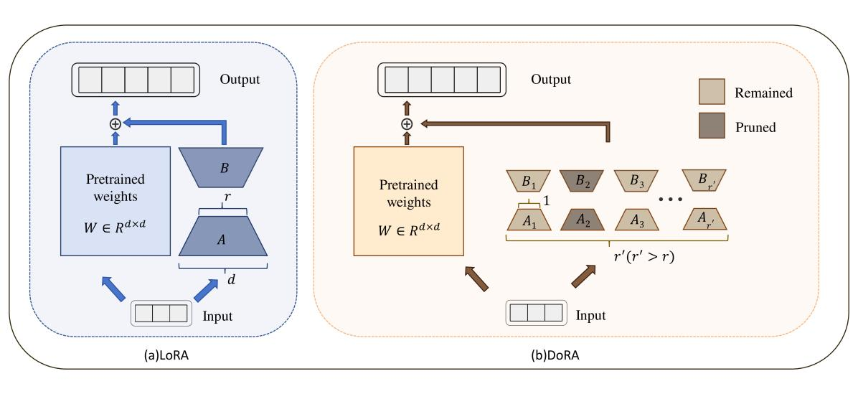
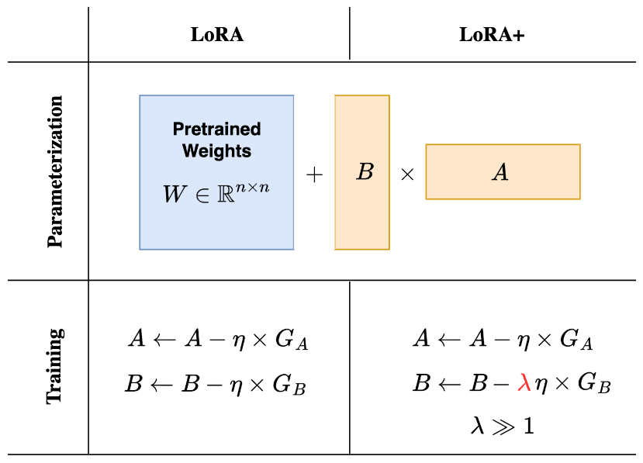
Advantages and disadvantages of LoRA+, DoRA, and standard LoRA
LoRA Key Benefits
- Reduces trainable parameters by 90–99%
- Lower GPU memory usage
- Faster training
- Easy task switching (swap adapters)
Limitations
- Limited expressiveness (rank bottleneck)
- May underperform on complex tasks
- Slower convergence in some cases

LoRA+ Key Benefits
- Matrix A and B learn at different speeds
- Better optimization dynamics
- Reduces instability
Limitations
- Slightly more tuning required
- Still limited by low-rank structure

DoRA Key Benefits
- Neural networks rely heavily on weight direction
- Separating magnitude → improves stability
- More expressive than LoRA

Effect on model accuracy and convergence
- LoRA:
  - Good baseline
  - May plateau early
- LoRA+:
  - Faster convergence
  - Better final accuracy
- DoRA:
  - Best performance on complex tasks
  - More stable training

Real-world use cases of each method
LoRA
- Chatbots
- Domain adaptation
- Quick fine-tuning tasks
LoRA+
- Production systems needing:
  - Faster convergence
  - Better stability
- Used in:
- Instruction tuning
- RLHF pipelines
DoRA
- High-precision tasks:
  - Legal NLP
  - Medical AI
  - Safety systems (like Llama Guard)

Why these techniques are important in modern LLM fine-tuning
Modern LLM Challenges
- Huge models (7B–70B parameters)
- Limited GPU memory
- Expensive training
These methods:
- Reduce cost
- Enable local fine-tuning
- Improve efficiency

